# Setting up Application Environment

# Create Sendgrid Account

| Team ID | PNT2022TMID02590 |
| --- | --- |
| Project Name | News Tracker application |

**Step1.**

Navigate To Https://sendgrid.com

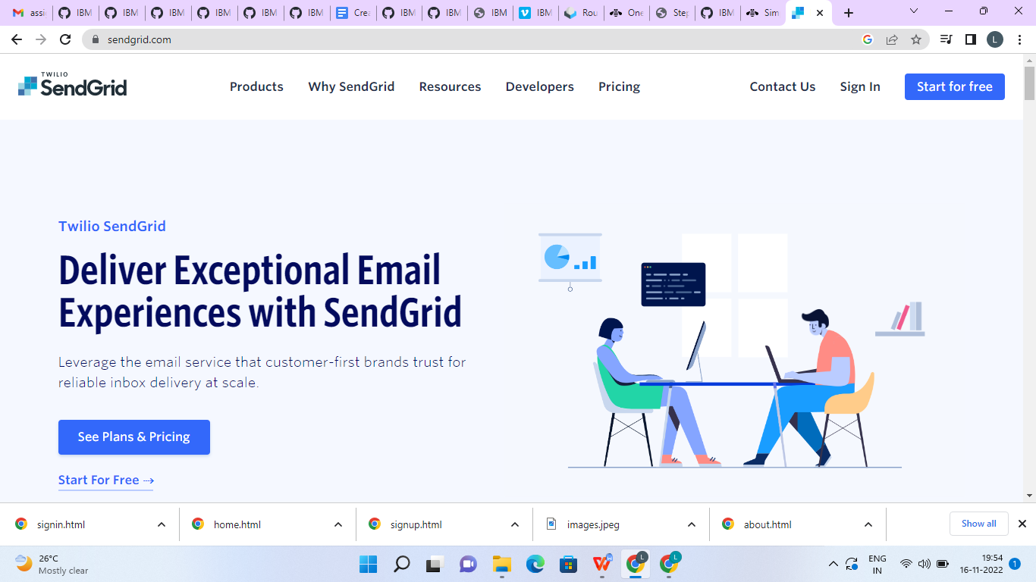

**Step2.**

Click on “Startforfree”and register yourselves by entering required details and click on create account

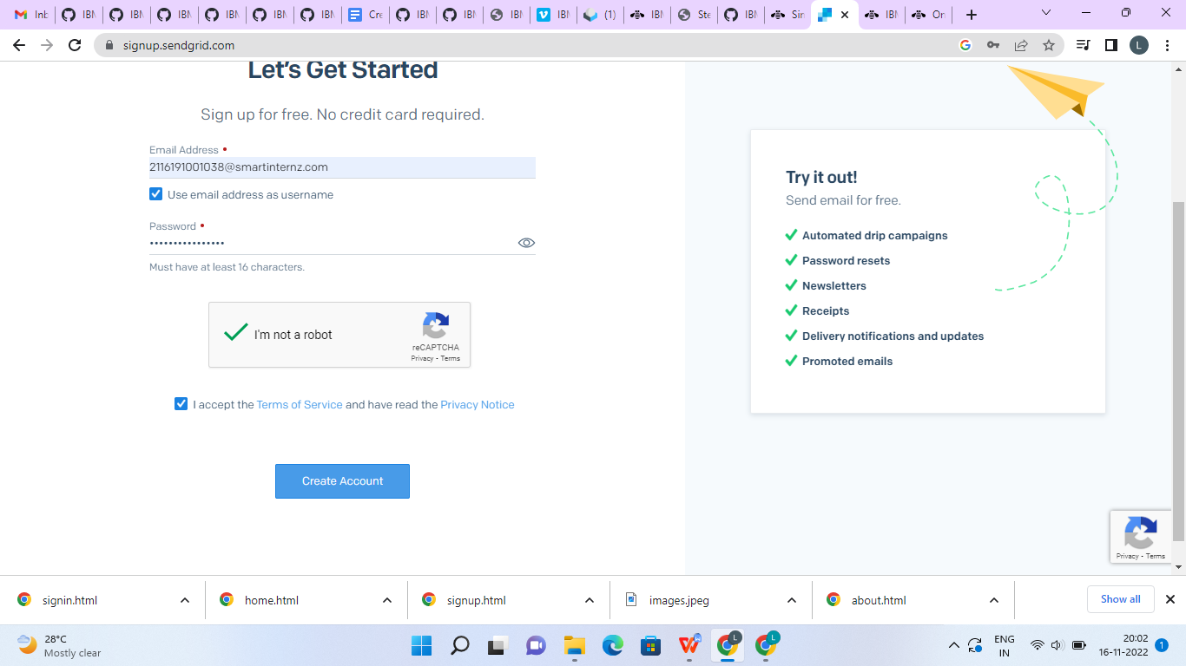

**Step3.**

Further fill all required details in next page and click on get started as shown below

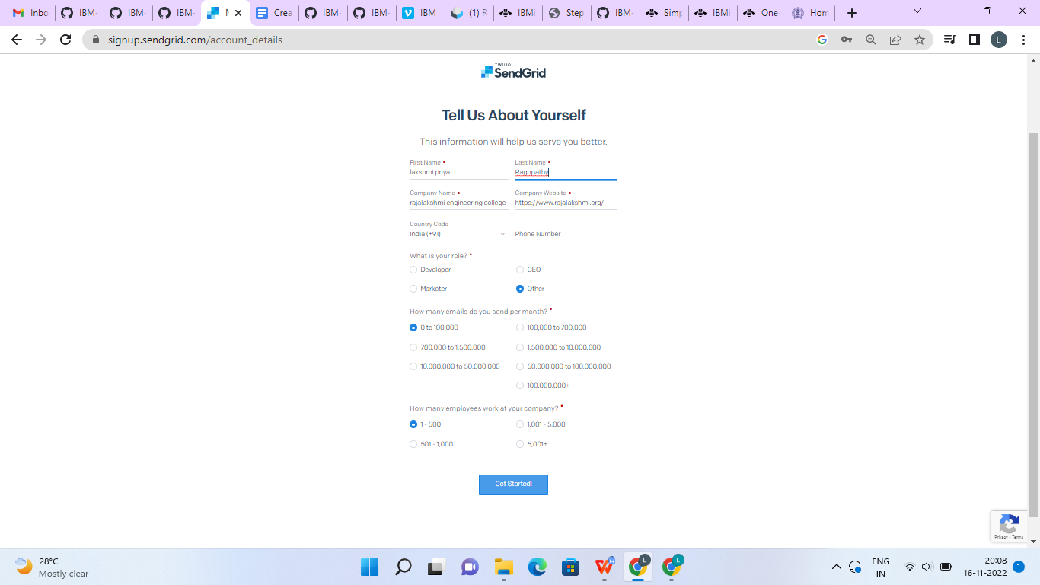

**Step 4.** That’s it you have created your SendGrid account and got access to dashboard

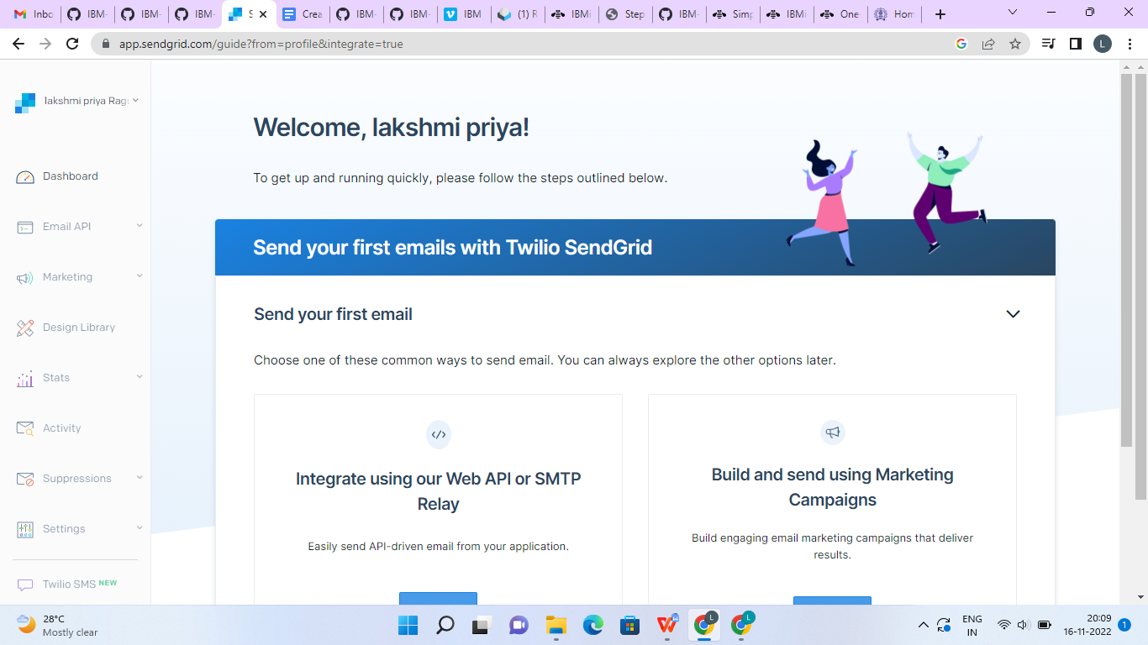

# Output:

SendGrid account created successfully.